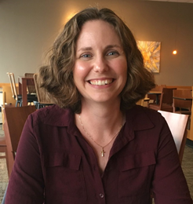
THRIVE CONFERENCE 2021
June 18-19 We are going VIRTUAL!
KEYNOTE SPEAKER
Reverend Kelly Legg

Do you know the definition of “thrive”?
It means to “grow or develop vigorously.” To “thrive” is to experience dynamic, exponential maturation. And that is the perfect word to describe the life-long process of transformation for a Jesus-follower. This year it is my privilege to join in this pursuit of Jesus with you, as together we seek to develop an external focus that enables us to thrive.
My life-verse comes from Ephesians 3:20-21. In that breathtaking prayer the apostle Paul gives God a new name. He declares that our God is “He who is able to do immeasurably more than we can ask or imagine, according to His power that is at work within us.” Do you know what He is able to do, friends? To heal the broken, cleanse the messy, comfort the hurting, and provide for the lacking. He is able to draw more people to Himself than we can fathom, according to His power that is at work within us.
That single promise is reason enough for us to invite Him to shift our gaze beyond our own selves to the people in front of us, community near us, and needs surrounding us. Because God is able to do more than we can imagine. You don’t want to miss this. So ‘grab’ your friends and register for this online experience! Registration is open online at abcopad.org, mailing coming soon!
For those who like to know the particulars about their speaker: I grew up in WV attending an ABC-USA church. I earned my undergraduate degree at Washington & Lee University and my Master of Divinity from Gordon-Conwell Theological Seminary. It has been my privilege to serve within ABCOPAD for more than a decade, first as pastor of First Baptist Church of Norristown and now as the senior pastor of the West Shore Baptist Church. You can find me on YouTube or at www.wsbc.org.
See you soon!
~ Pastor Kelly
CONFERENCE SCRIPTURE
‘Let each of you look not to your own interests, but to the interests of others.’ Philippians 2:4 NRSV

